1. **Login/Home Page :-**

* In this Page Employee who is interested to apply for Affordable Tuition Assistance Program (ATAP) have to create a profile by clicking “CREATE PROFILE”.

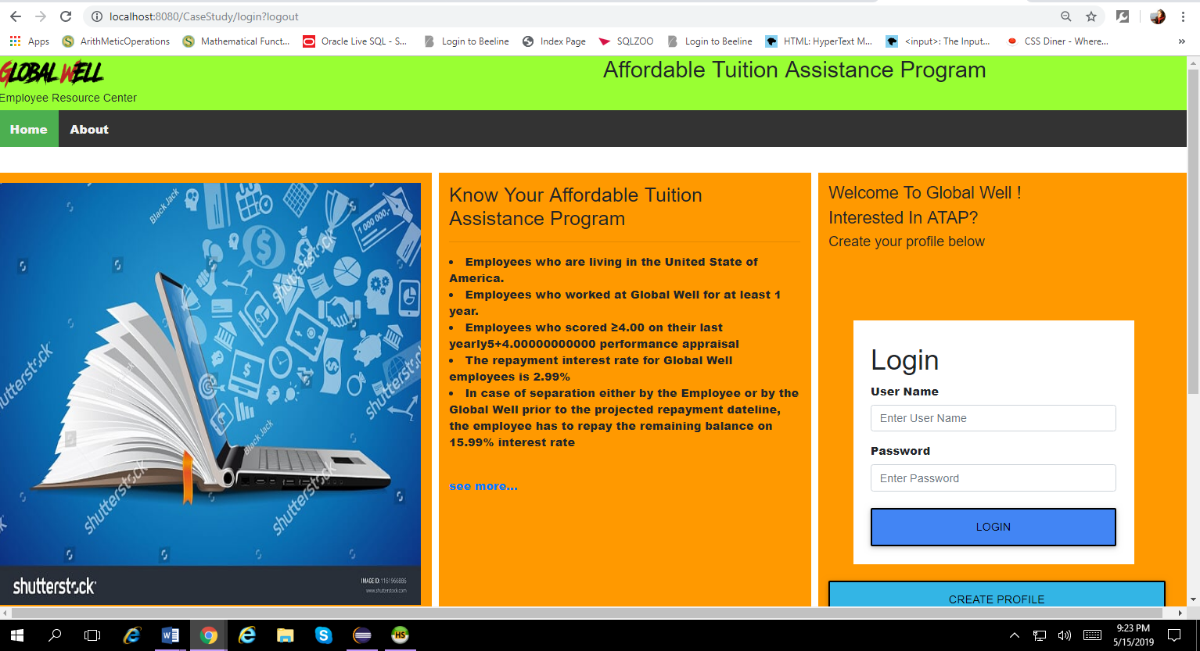

* When you click on Seemore you will go to the following page with more info.

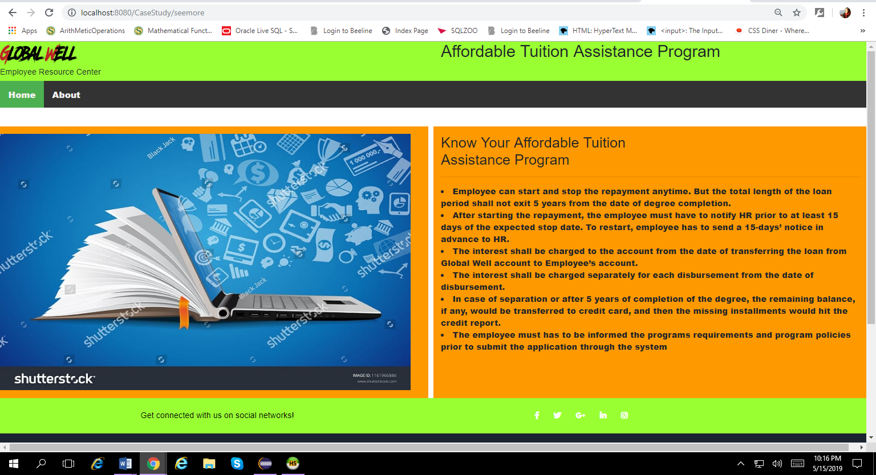

1. **Create Profile Page –**

* In this page User/Employee have to fill out the information all the fields are required.
* The ” **Username”** will be your Login Username and Password is- **123456**.
* So remember your Username.

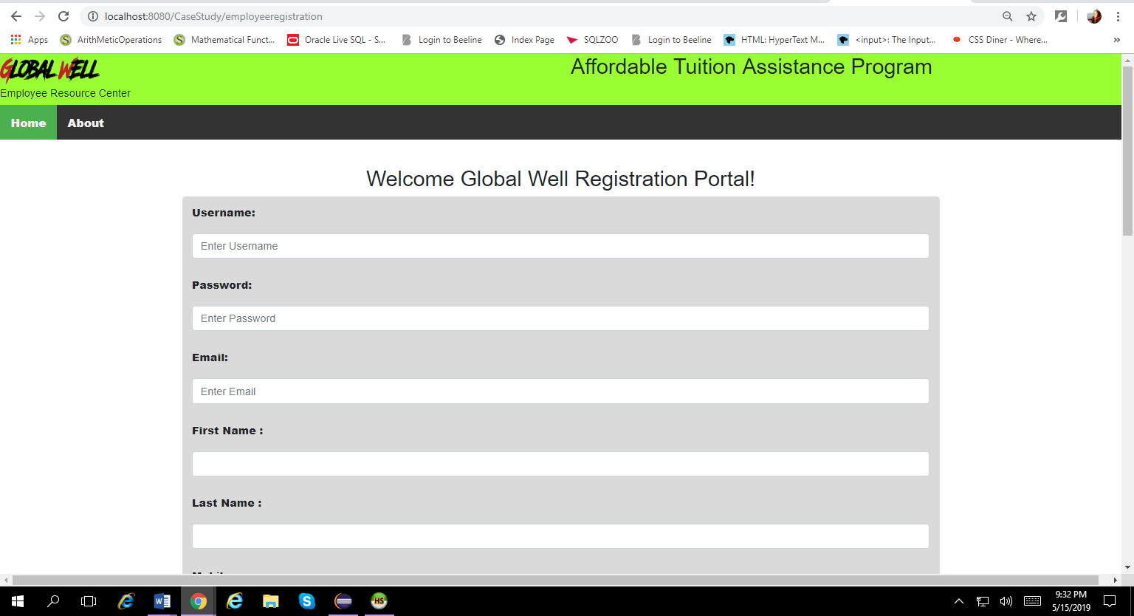

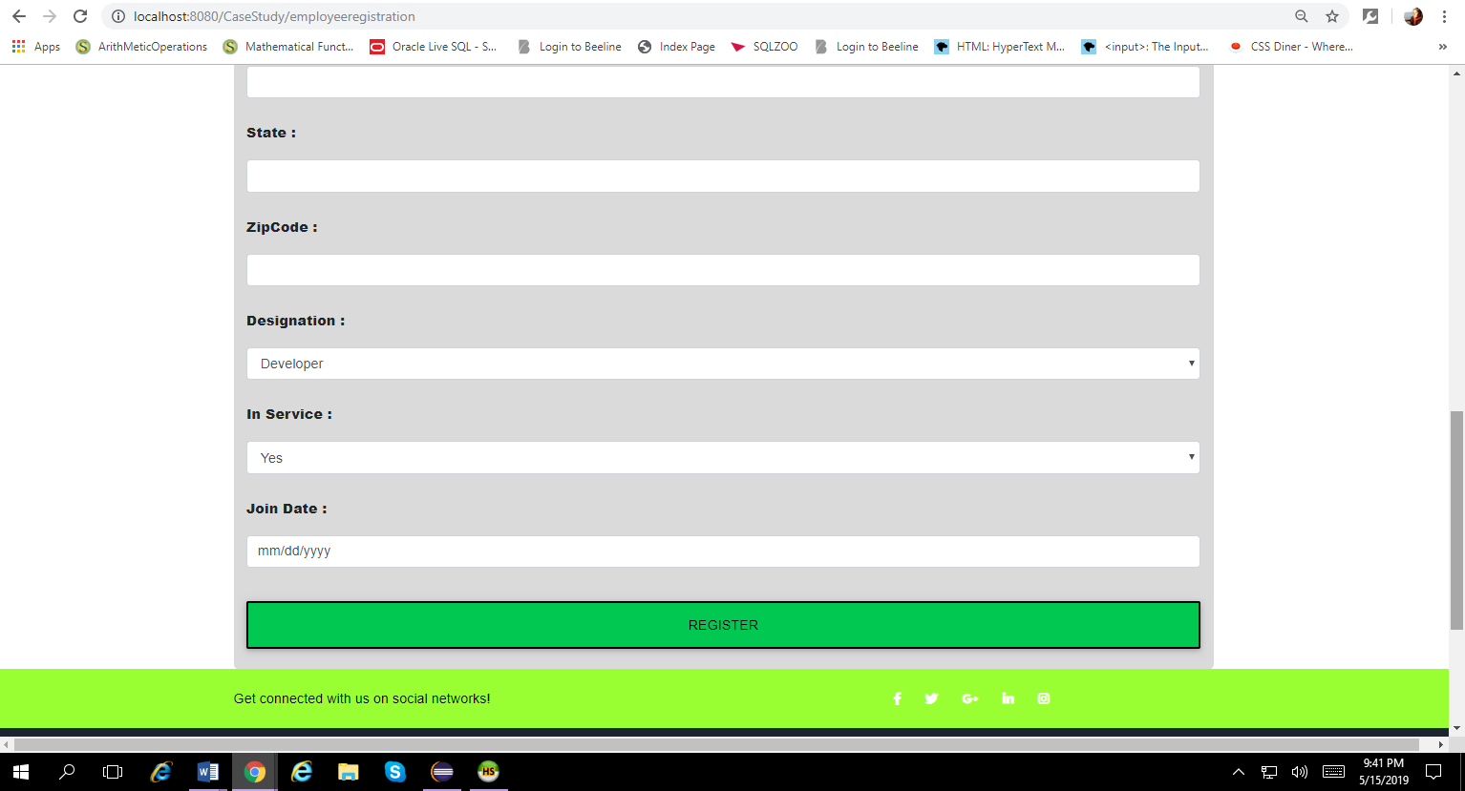

1. **After Registration Page :-**

* Now time to login as user/Employee---- Use your username that you have used while creating profile and password is ---- 123456
* I already have a User permitted as a ADMIN ------ Username- **Arshan,** Password -

**123456.**

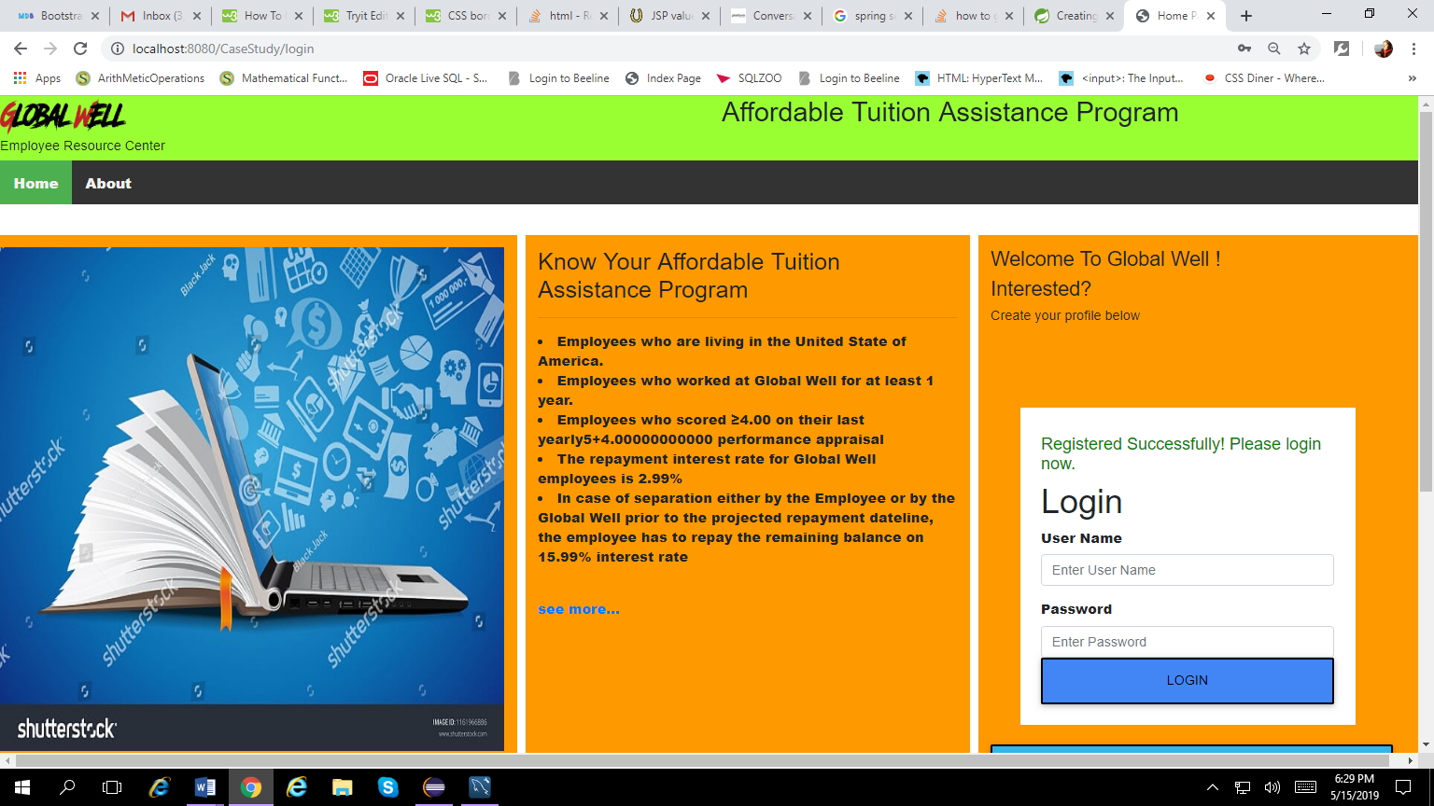

1. **After Login Page** ------- now check your eligibility for the Loan Application by clicking on “AM I ELIGIBLE” when done click on Apply to go to the Application page.

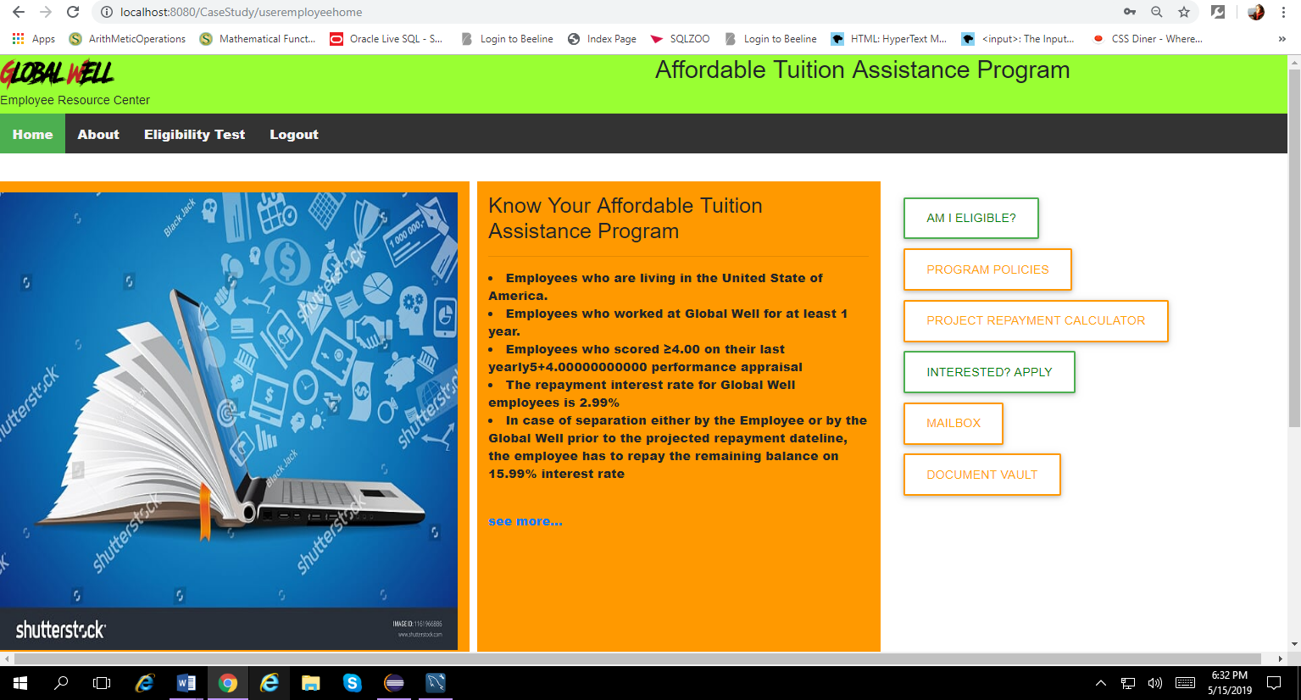

1. **Eligibility Page:** All the options should be yes if one is checked as NO then you click submit button it will show you a message that you are not eligible. If all options are checked as a yes by default then you can click the submit button and it will take you to a pdf file where you can see details.

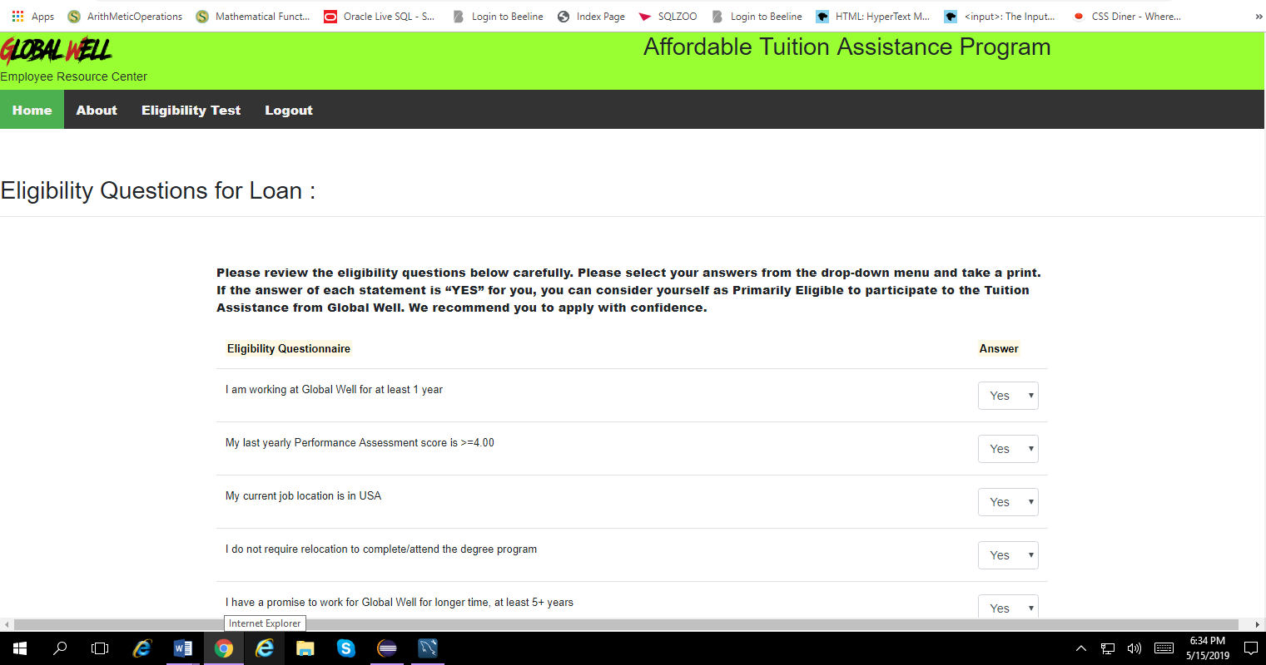

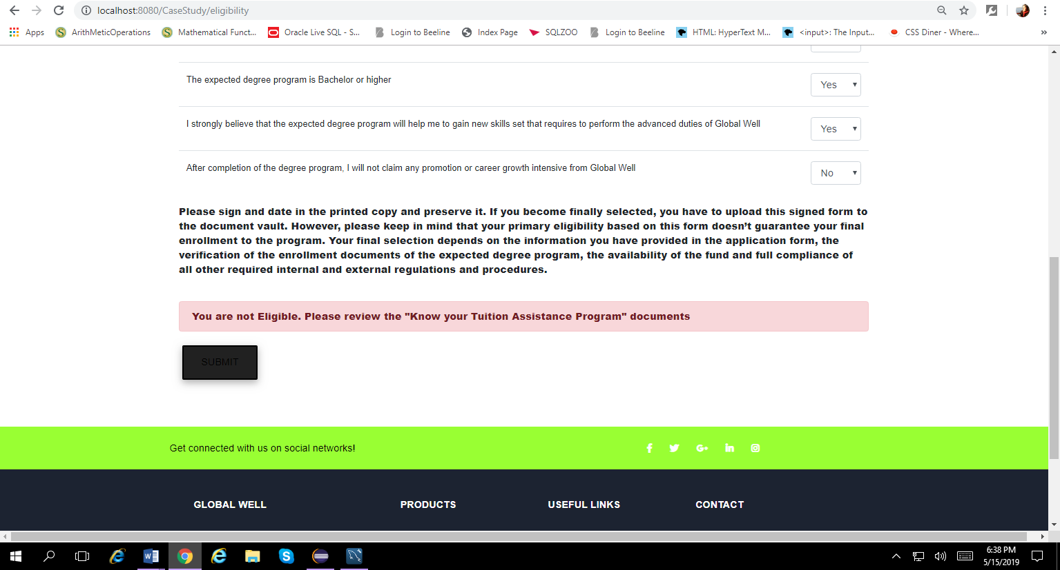

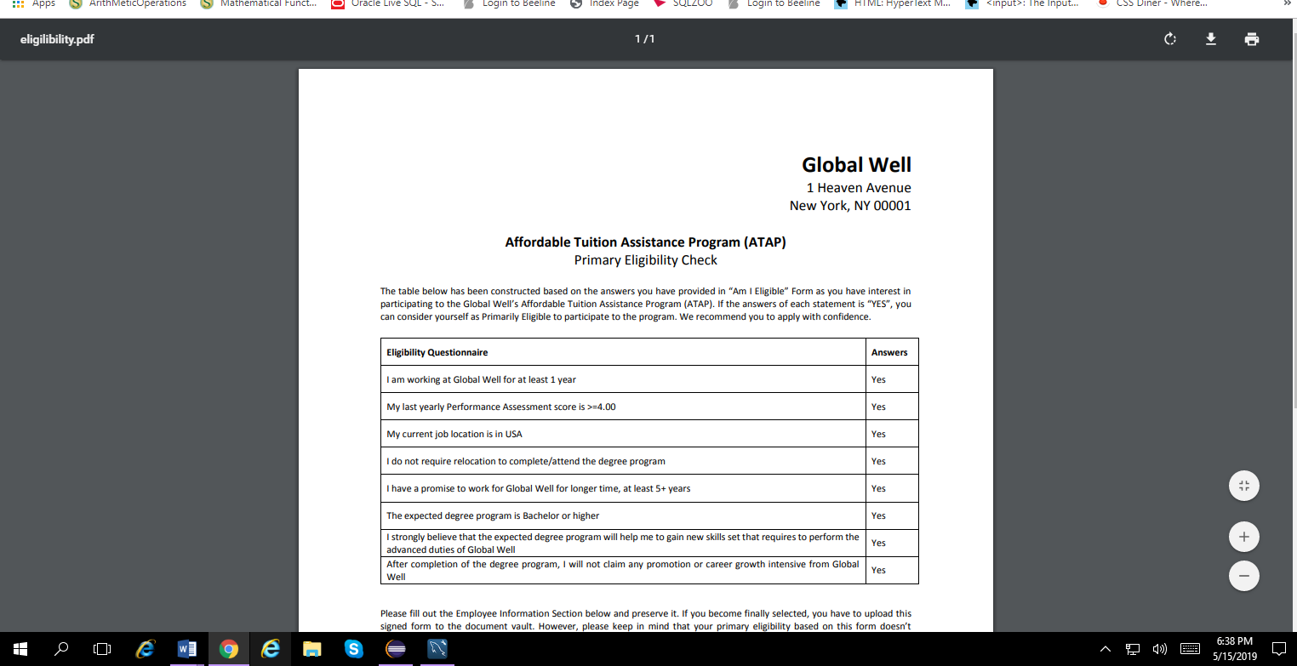

1. **Interested? Apply Button:** after clicking on that button you will see the ATAP Application page

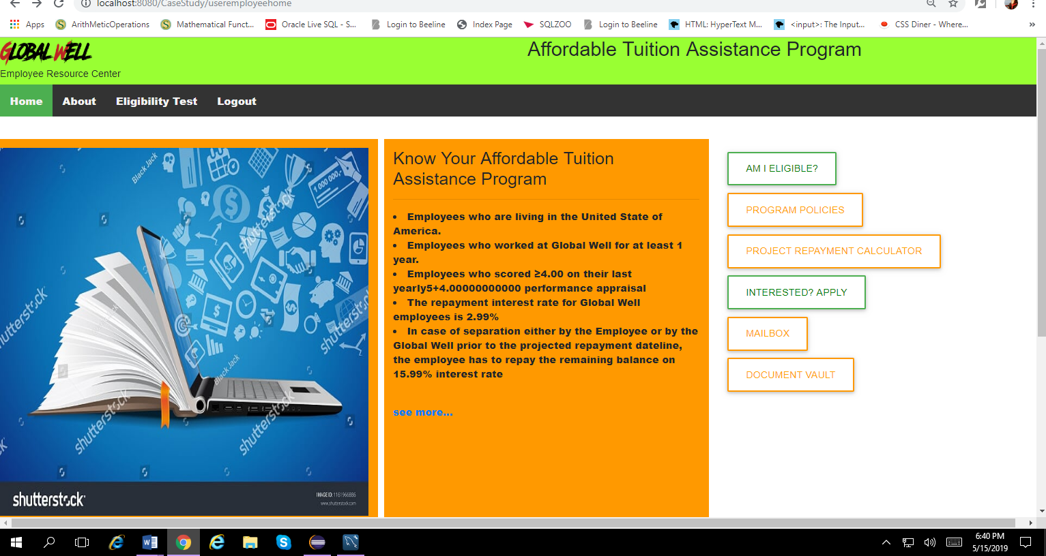

1. **ATAP Loan Application Page:**

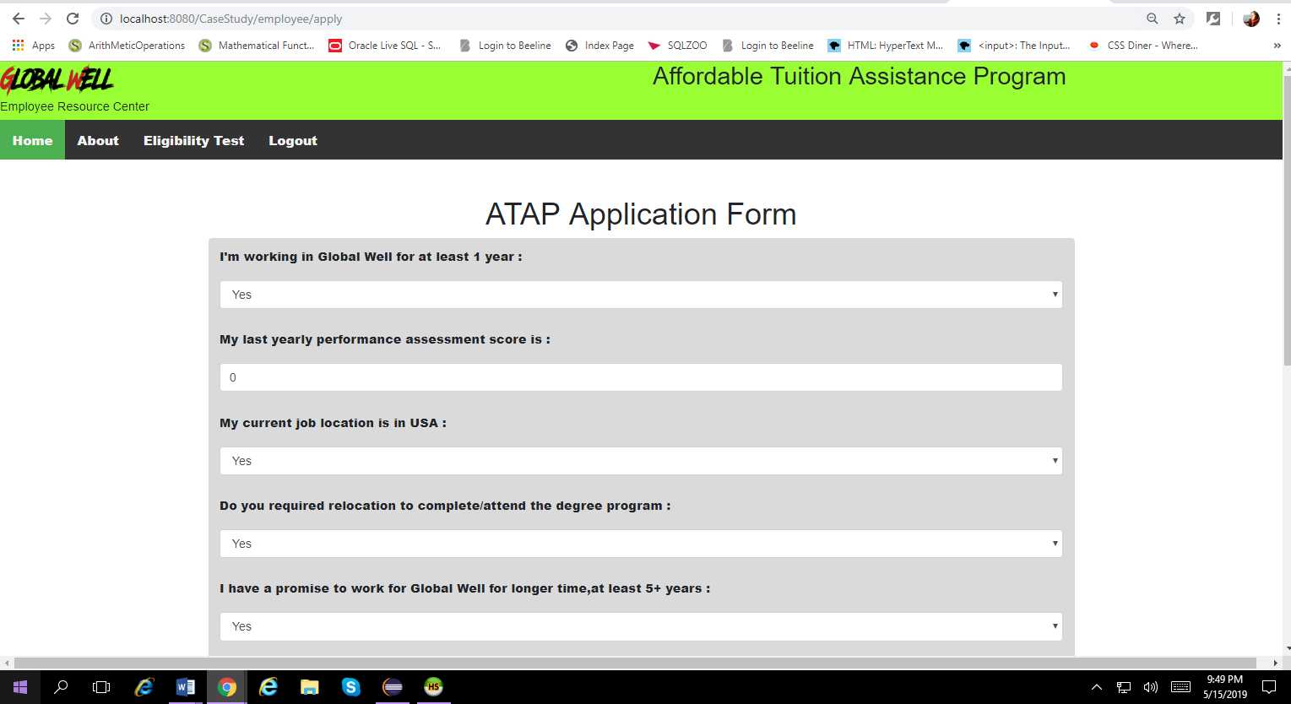

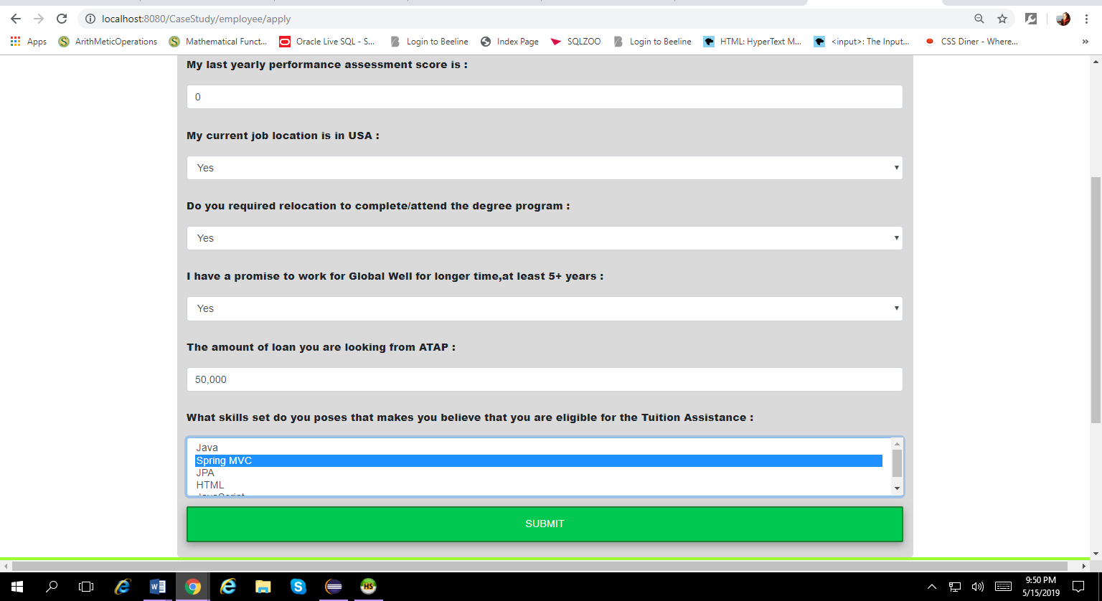

1. **Apply Success Page:**

* In this page user/Employee will see some details and Application Successfully submitted message.

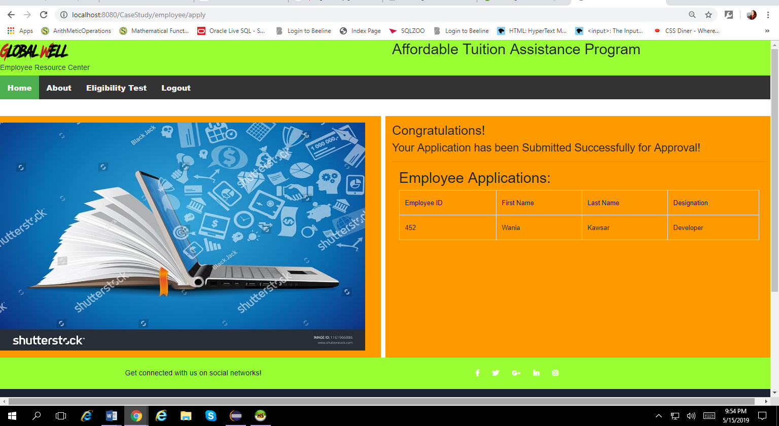

IF you already have a profile with one email address you can’t use it again if you do that you will see this page:-

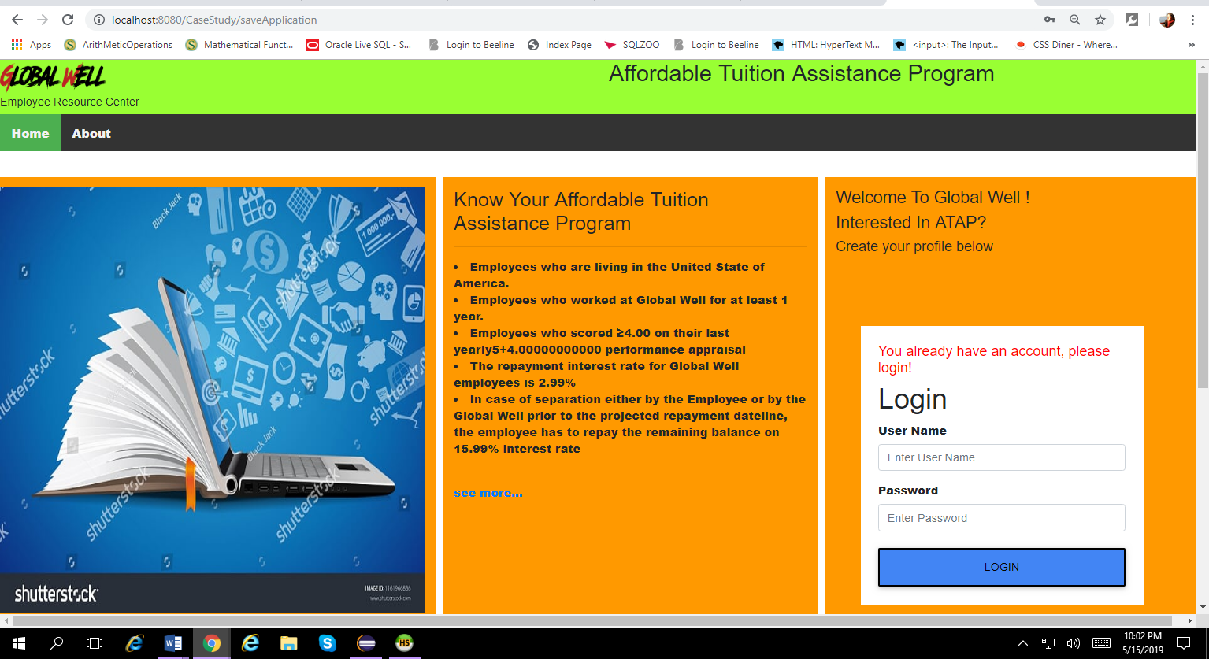

**Only Admin can see this page!**

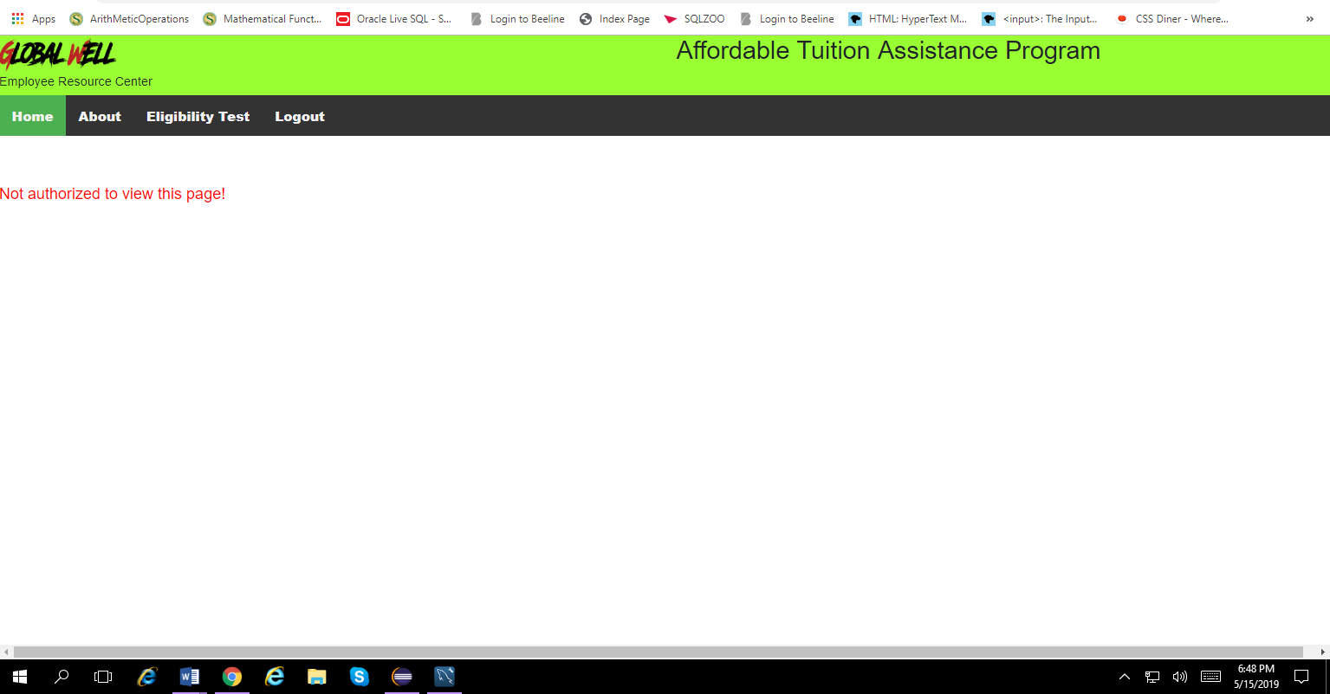

**About Page :-**

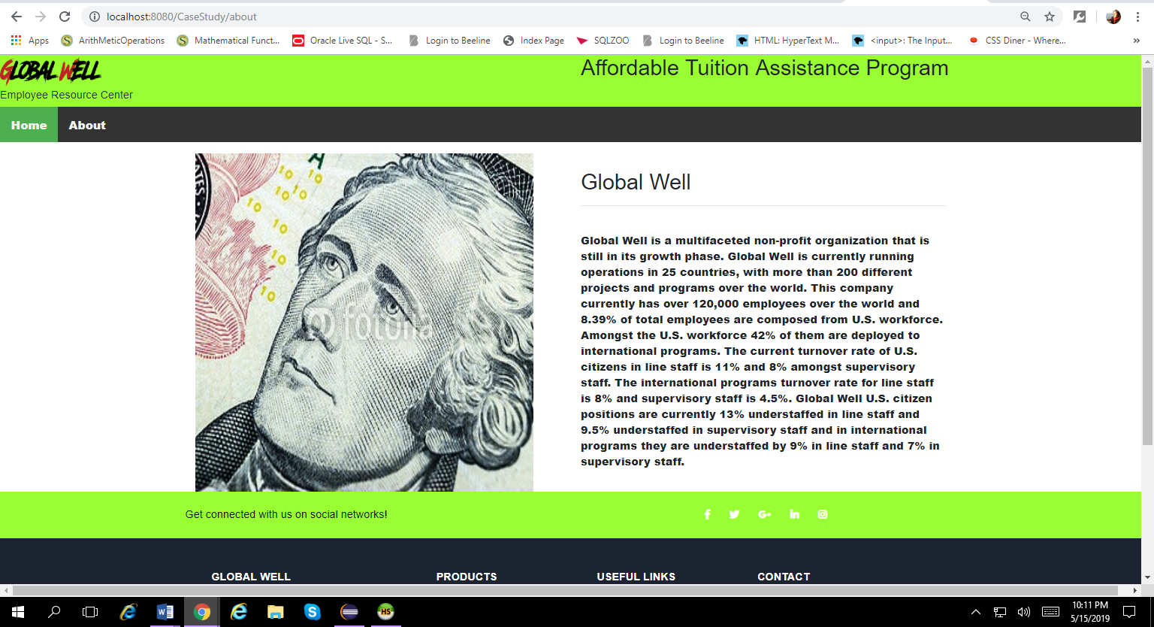

**AllEmployees :-**

* When you are logged in as an “**Admin”** you will see all the list of the Employees.

